Maths Homework Answers – Sameer

16/7/20

Q1:

Model Length : Car Length

1. : 25

*18 *18

18 : **450**

The actual length of the car is 4.5m

Q2:

Length : Width

5 : 3

*18 *18

90 : **54**

The width of the field is 54 m

Q3:

Didn’t understand

Q4:

Pros : Amatuers

5 : 7

Amateurs = 7/(5+7)*60

= 7/12 * 60

=35 amateur golfers

Q5:

Tin : Zinc : Lead

15 : 4 : 1

Tin = 15 / (15+4+1) * (5*1000) *coverting into kgs for easier calculations*

= 15 / 20 * 5000

=3,750 kgs

3750 kgs (3.75 tonnes) of tin will be required to make 5 tonnes of alloy

Q6:

Cordinal : Water

1. : 9

/5 /5

0.4 : **1.8**

1.8 litres of water should be added

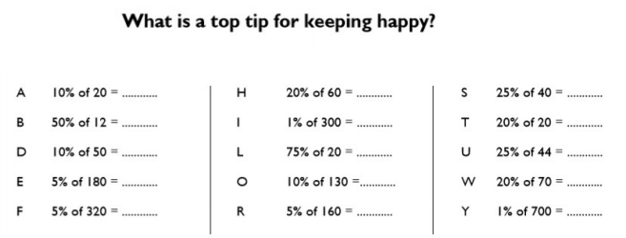

A = 2

B = 6

D = 5

E = 9

F = 16

H = 12

I = 3

L = 15

O = 13

R = 8

S = 10

T = 4

U = 11

W = 14

Y = 7

Phrase is :

**Treat others as you wish to be treated yourself**